CaHolter Recorder
CardioScan’s Digital RZ153+ Holter Monitor Data Sheet

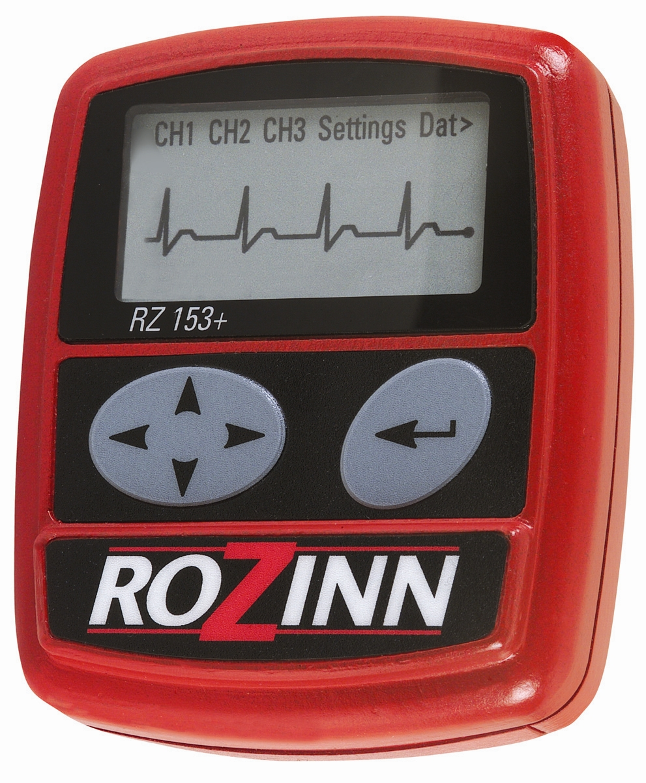
Accurate ECG Studies from Holter Data

♥ Removable CompactFlash Card
♥ Fast Data Transfer for
Quick Recorder Turnaround
♥ Built-in Keypad for On-site
♥ Programming and Patient ID
♥ Real-Time Pacemaker Detection
♥ Small, Lightweight Design
♥ NO DATA COMPRESSION
♥ Multiple Recording Modes
♥ Multifunction LCD Display
♥ View ECG, Check Hookup on-Screen
♥ Software Upgradable
♥ Meets AAMI Standard EC-38
for Diagnostic Quality ECG
♥ 3-Lead Recording for 1 – 3-Days

CardioScan’s RZ153+ Digital Holter Recorder is a 3-Lead Digital Holter recorder. The CompactFlash recording medium provides nonvolatile storage of ECG data for 24, 48, or 72 hours. The removable CompactFlashCard allows fast data transfer and frees the Recorder for immediate reassignment. The built-in Keypad and LCD screen enables remote encoding of the Patient’s first and last name, DOB, ID, and selection of program mode. With the Patient ID right on the CompactFlash, you no longer risk confusing ECG data from different patients. The large LCD screen displays all channels of ECG to confirm hookup, Battery Status, and Mode selection. During recording, the screen displays the current day, date, time, and the time remaining in the Holter test. All RZ153+’s provide real-time, Pacemaker spike detection during Holter recording. All of CardioScan’s Digital Holter Recorders meet the strict AAMI EC-38 standard for frequency response—ECG Machine quality tracings in an ambulatory device! ECG recording and storage are accomplished with NO DATA COMPRESSION. The small CompactFlash may be used for thousands of recordings.

SPECIFICATIONS
RECORDING DURATION: Up to 72 hours
RECORDING BANDWIDTH: .05-(60-180) Hz, -3dB (programmable)
A/D RESOLUTION: 8 to 12 Bit, Programmable, No Compression
SAMPLING RATE: Up to 1024sps
GAIN SETTINGS: 2X, 1X, 2X
PATIENT CABLE: 20-Pin Connector 7 Lead, Snap-On
STORAGE MEDIUM: Removable CompactFlash Card
STORAGE CAPACITY: 64 MB - 2 GB
POWER: 1 AA Alkaline Battery or 1 AA Lithium Battery
CHANNELS: 2 or 3
WEIGHT: 113 grams (4 oz) with the battery
DIMENSIONS: 71mm • 95mm • 20mm
(2.78in • 3.75in • 0.78in)

